Work 5 Кириленко Константин 351



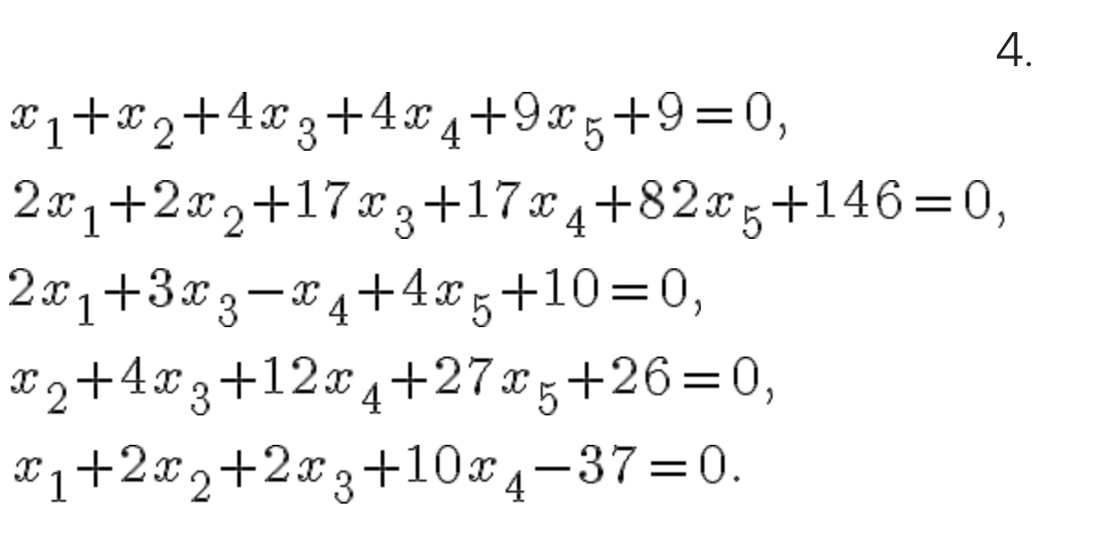

void DummyDataInitialization(double\* pMatrix, double\* pVector, int Size) {

pVector[0] = -9;

pVector[1] = -146;

pVector[2] = -10;

pVector[3] = -26;

pVector[4] = 37;

pMatrix[0] = 1;

pMatrix[1] = 1;

pMatrix[2] = 4;

pMatrix[3] = 4;

pMatrix[4] = 9;

pMatrix[5] = 2;

pMatrix[6] = 2;

pMatrix[7] = 17;

pMatrix[8] = 17;

pMatrix[9] = 82;

pMatrix[10] = 2;

pMatrix[11] = 0;

pMatrix[12] = 3;

pMatrix[13] = -1;

pMatrix[14] = 4;

pMatrix[15] = 0;

pMatrix[16] = 1;

pMatrix[17] = 4;

pMatrix[18] = 12;

pMatrix[19] = 27;

pMatrix[20] = 1;

pMatrix[21] = 2;

pMatrix[22] = 2;

pMatrix[23] = 10;

pMatrix[24] = 0;

}

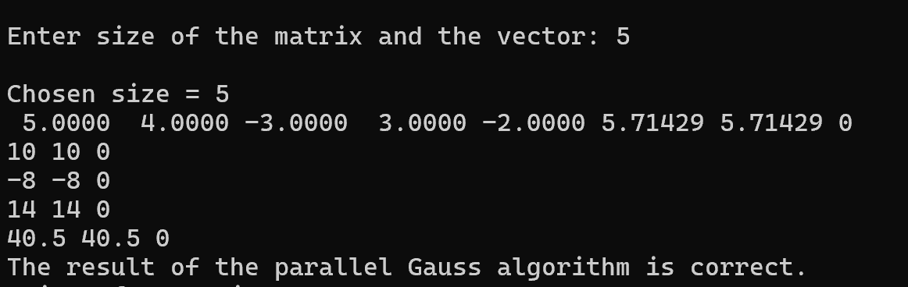

Решение с помощью метода Гаусса верно.